# UI Development Accelerator

## Slide 1: The Challenge: Bridging Design & Development

* **Manual UI implementation is slow & costly:** Often taking 40-60% of frontend development time.

* **Design fidelity loss:** ~30% of design details can be lost or misinterpreted during manual handoff.

* **Inconsistencies creep in:** Maintaining design system compliance manually is difficult and error-prone.

* **Bottlenecks:** Design changes create significant implementation backlogs.

* **High Cost:** Manual translation costs teams $120K-$180K+ annually in development resources.

* **Traditional tools lack deep understanding:** Basic code snippets often require heavy refactoring.

---

## Slide 2: Our Vision: LLM-Powered UI Generation

* **AI-Powered Design-to-Code Pipeline:** Seamlessly connect Figma designs to production-ready code using Large Language Models (LLMs).

* **FigmaDev Accelerator:** A platform combining a smart Figma plugin with external AI processing (e.g., Cursor AI).

* **Goal:** Drastically reduce manual effort, ensure high fidelity, and accelerate development cycles.

---

## Slide 3: The Solution: FigmaDev Accelerator Workflow

* **Two-Part System:**

1. **Figma Plugin:** Intelligently extracts comprehensive design data (styles, layout, tokens) directly within Figma's Dev Mode.

2. **AI Processing Engine:** Takes the structured **Design Data Package** and combines it with **User Stories/Requirements** using LLMs (like Cursor AI) to generate sophisticated UI code.

* **Visual Workflow:**

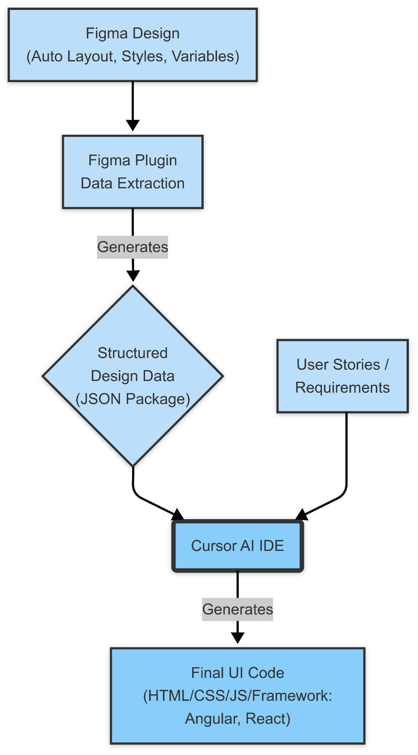

*The **Design Data Package** is the key link, providing rich, accurate context from Figma to the AI.*

---

## Slide 4: Architecture Overview: From Design to Code

* **The Foundation:** High-fidelity data extraction from the design source-of-truth.

* **AI Enhancement:** Leveraging LLMs with combined **design data + user requirements** for intelligent code generation.

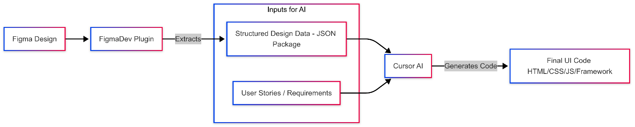

* Key Principle: The plugin provides the *exact*, company-approved design elements as a robust foundation. Combining this with user requirements allows the AI (Cursor) to perform accurate "vibe coding" and generate high-quality, functional UI.

**Slide 5: Plugin Architecture & Tech Stack (Part 1 Focus)**

* How the Plugin Works: Runs inside Figma, interacting directly with the design file.
* Core Components: Configuration, UI (optional), and the main code logic using Figma's API.
* 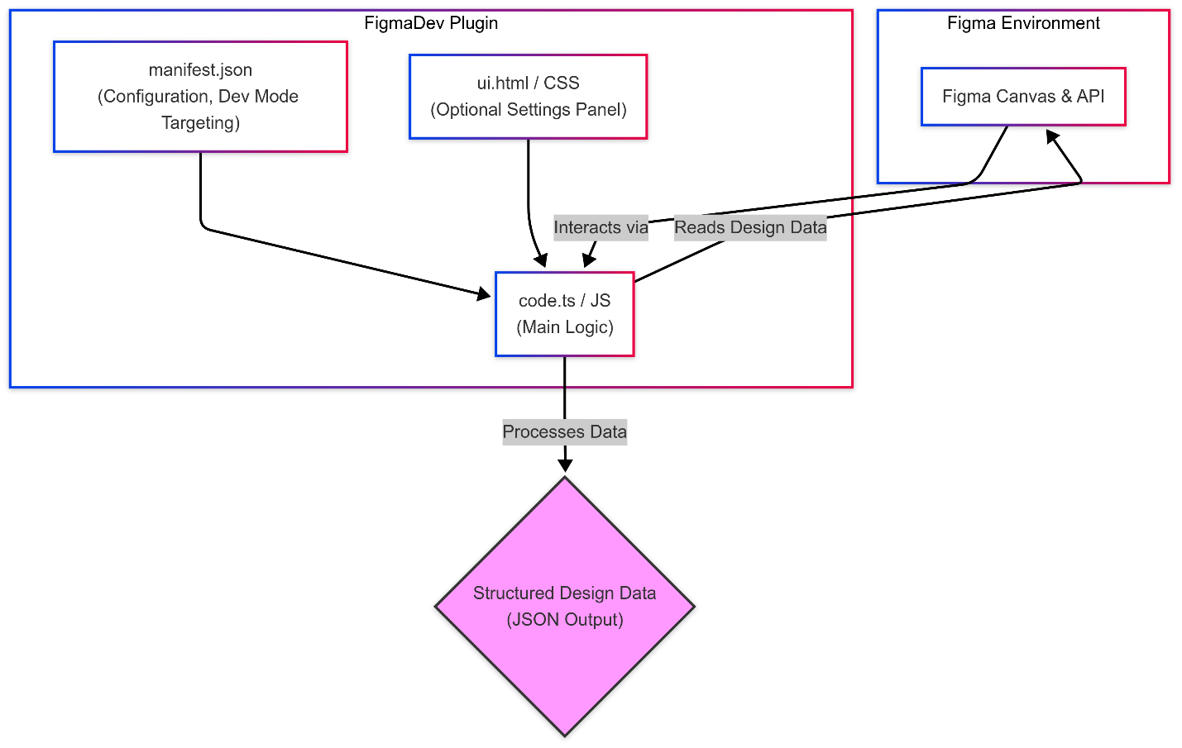
* Technical Stack:
  + Figma Plugin API: Core interface for accessing design data.
  + TypeScript: Preferred language for type safety with the API (JavaScript also possible).
  + HTML / CSS: For building the optional plugin settings UI (ui.html).
  + Node.js / npm: For development environment, build process, managing dependencies.
  + Bundler (e.g., Webpack, esbuild): Often used to compile TypeScript/JavaScript and bundle code for Figma.

**Slide 6: Step 1 - Design Intelligently in Figma**

* Foundation is Key: Leverage Figma's best practices.
* Auto Layout: Essential for generating responsive layouts.
* Consistent Naming: Use clear, predictable layer names for better mapping.
* Clean Hierarchy: Organize elements logically in Frames and Groups.
* Styles & Variables: Apply design system styles (colors, typography, effects) and utilize Figma Variables for tokens.

**Slide 7: Step 2 - Intelligent Data Extraction (Plugin)**

* The Figma plugin extracts more than just basic styles:
  + HTML Structure: Inferred semantic structure based on layout and naming.
  + CSS Styling: Detailed rules including layout, fills, strokes, effects, typography.
  + Design Tokens: Colors, typography, spacing, radii (from Styles & Variables).
  + Layout Specs: Auto Layout properties (direction, gap, padding, alignment).
  + Component Info: Names, variants, properties (based on naming conventions).

**Slide 8: The AI Data Package: Linking Figma to Code Context**

* What we extract: This structured JSON package translates your Figma design into data the AI understands.
* Why it's needed: Provides the essential context (styles, layout, structure) for accurate AI code generation.

{

"metadata": { // General info about the extraction

"source": "FigmaDev Accelerator v1.0"

},

"structure": { // How elements are nested (like Figma layers)

"html_tree": "<div class='container'>...</div>" // Basic HTML structure guess

},

"styling": { // Visual appearance details

"css": ".container { display: flex; ... } .button {...}", // CSS rules from Figma properties

"designTokens": { // Maps directly to Figma Styles & Variables

"colors": {"primary": "#426B1F"}, // From Color Styles

"typography": {"heading1": {"fontFamily": "Newsreader"}}, // From Text Styles

"spacing": {"medium": "16px"} // From Variables or naming conventions

}

},

"layout": { // How elements are arranged

"autoLayout": [ // Details from Figma's Auto Layout panel

{"nodeId": "12:34", "direction": "row", "gap": 16, "padding": [8, 16]}

],

"constraints": [] // Figma constraint settings (if applicable)

},

"components": [ // Information about Figma Components

{"name": "ProductCard", "nodeId": "56:78", "variants": ["default", "hover"]} // Component name & variants

],

"userPrompt": "Generate a responsive React component..." // Optional developer instructions

}

**Slide 9: Why Not Just Use AI Directly? The Need for Foundation**

* Challenge: AI like Cursor is powerful, but lacks direct access to your specific, approved Figma design details (the *exact* styles, tokens, layout specs).
* Problem with AI Alone:
  + Generic Output: Without design context, AI generates code based on general knowledge, not *your* specific design system or visual requirements.
  + Inaccuracy: It might guess styles or layouts, leading to visual inconsistencies and non-compliance.
  + Requires Heavy Prompting: You'd need extremely detailed text prompts describing every visual aspect, negating the efficiency gains.
* Our Solution's Advantage: The Figma Plugin provides the critical foundation – the structured, accurate design data.
* Successful "Vibe Coding" Needs:
  + Rich Design Context: The extracted data package (styles, tokens, layout).
  + Functional Requirements: User stories defining *what* the UI should do.
* Result: AI (Cursor) can accurately translate the design *and* implement functionality, building good products efficiently.

**Slide 10: Part 2 - AI-Powered Vibe Coding (Angular Example)**

* Leveraging the Foundation: The detailed Design Data Package (from Part 1) provides the essential context for the AI.
* Input Fusion: Combine the structured design data with specific User Stories or functional requirements.
* AI IDE Integration (e.g., Cursor): Utilize AI-native IDEs to process the combined input.
* "Vibe Coding": The rich context allows the AI to understand the *intent* (the "vibe") and generate not just snippets, but complete, working UI components/pages.
* Target Output: Generate functional Angular components (or other frameworks) incorporating:
  + Correct HTML structure & CSS (based on design data).
  + Basic component logic inferred from user stories.
  + Integration of design tokens.

**Slide 11: Step 3 - AI Processing & Code Generation (General)**

* External Application (e.g., Streamlit) or IDE (e.g., Cursor): Provides the interface for processing.
* AI Model Choice: Flexibility to use powerful models like Cursor AI, GPT-4, Gemini, etc.
* Context is King: The structured JSON (and user stories in Part 2) provides rich context for the LLM.
* Sophisticated Prompting: Multi-step prompting guides the AI:
  1. *Analyze* the design system tokens and structure.
  2. *Incorporate* user story requirements.
  3. *Generate* semantic HTML/Component structure (e.g., Angular).
  4. *Apply* styling using extracted CSS and tokens.
  5. *Optimize* for responsiveness based on Auto Layout data.
  6. *Enhance* for basic accessibility (ARIA roles based on structure).

**Slide 12: The Output: Production-Ready Scaffolds**

* High-Quality Code: Semantic HTML, well-structured CSS (or framework-specific code like Angular).
* Design System Integration: CSS Variables or framework equivalents generated from tokens.
* Responsiveness: Layout code derived from Auto Layout principles.
* Accessibility: Basic structure supporting ARIA standards.
* Maintainability: Cleaner, more understandable code than basic snippets.

**Slide 13: Ensuring Quality & Compliance: CI/CD Integration**

* Generated Code is Just the Start: While accelerated, the output needs validation.
* Automated Checks: Integrate generated code into a customized Jenkins Pipeline (or similar CI/CD tool) for automated quality and security gates.
* Pipeline Stages Include:
  + Static Code Analysis (SAST): Scan code for security vulnerabilities (e.g., Checkmarx).
  + Dependency Scanning (SCA): Check libraries for known vulnerabilities (e.g., Nexus IQ / SonarQube Dependencies).
  + Code Quality Analysis: Measure maintainability, complexity, standards adherence (e.g., SonarQube).
  + Container Security (if applicable): Scan container images for vulnerabilities (e.g., Twistlock / Prisma Cloud).
* Gated Deployment: Code is only pushed to environments (Dev, QA, Prod) after passing all required pipeline checks.
* Result: Ensures the final product adheres to company standards, security guidelines, and quality benchmarks.
* 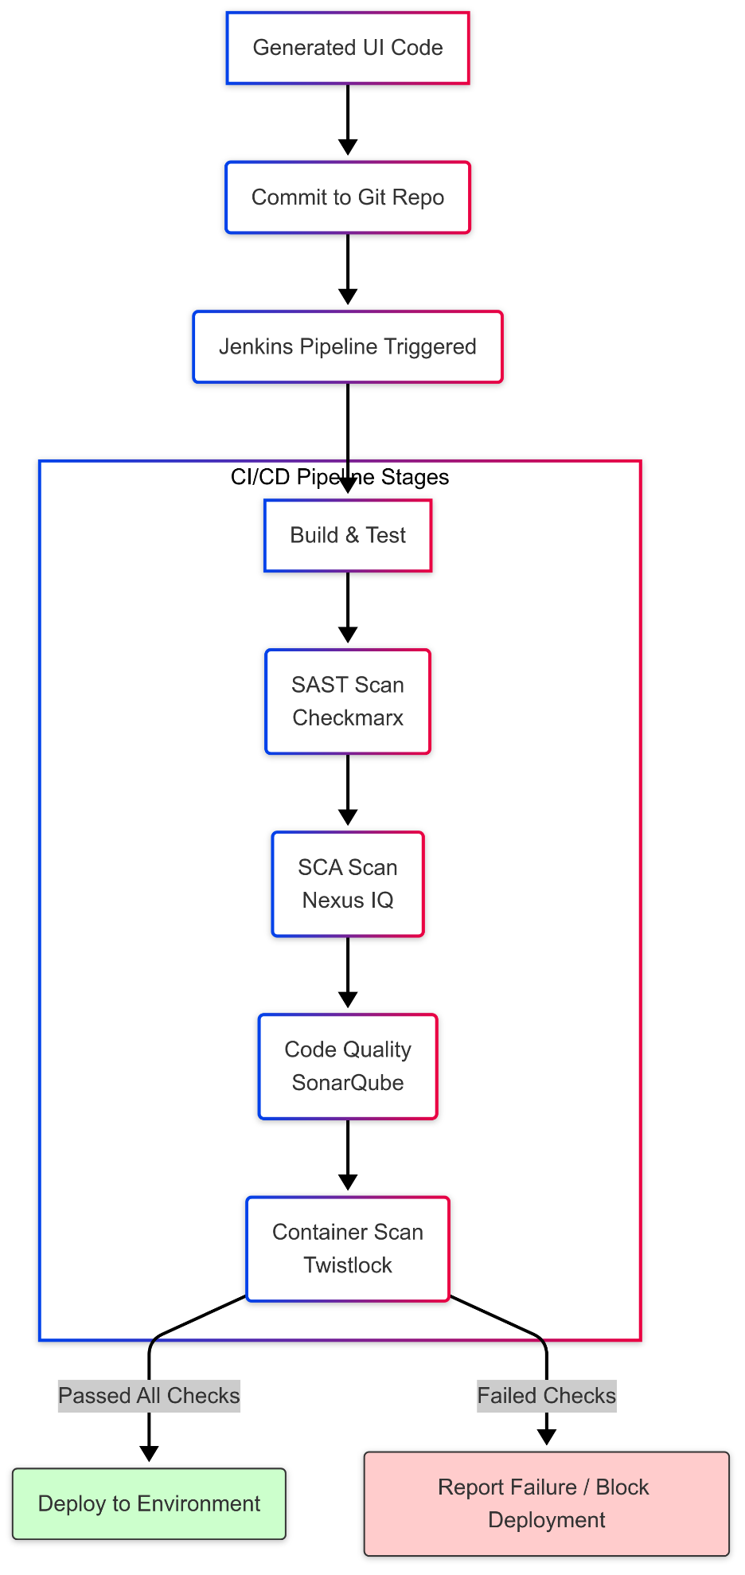

**Slide 16: Transforming the Workflow**

* Developer Experience:
  + Shift focus from tedious CSS/HTML to valuable business logic.
  + Reduced friction & faster feedback loops with designers.
  + Higher job satisfaction.
* Design Team Benefits:
  + More creative freedom and iteration without dev bottlenecks.
  + Guaranteed implementation of the design system.
  + Faster prototyping and validation cycles.
* Technical Leadership Benefits:
  + Reduced technical debt via consistent, maintainable UI code.
  + Enforced standards and best practices.
  + More predictable development timelines.

**Slide 19: Future Directions & Enhancements**

* Direct LLM Integration in Plugin (Part 1): Embed GenAI/LLM capabilities directly within the Figma plugin to generate framework-specific code (e.g., Angular HTML, React JSX) during the initial extraction, reducing reliance on basic HTML/CSS output.
* Templated User Stories (Part 2): Develop standardized templates for user stories focused on UI functionality. Feeding these alongside design data will provide richer context for AI "vibe coding," leading to more complete and accurate UI logic generation.
* Enhanced Component Logic: Improve AI's ability to infer and generate basic component state, event handlers (e.g., @Output in Angular), and data binding based on design patterns and templated stories.
* Design System Versioning & Validation: Align code generation with specific design system versions and potentially validate generated code against DS rules.
* Interaction & Animation Mapping: Translate basic Figma prototype interactions (clicks, hovers) and simple animations into corresponding framework code snippets.
* Advanced Accessibility Generation: Move beyond basic roles to generate more comprehensive ARIA attributes and potentially integrate automated accessibility checks.
* Theme Switching Support: Generate code that easily supports light/dark mode or other themes defined using Figma Variables.
* Bi-Directional Sync (Exploratory): Investigate feasibility of reflecting structural code changes back into Figma (highly complex).

**Slide 20: Call to Action & Q&A**

* Opportunity: Revolutionize your design-to-code workflow.
* Pilot Program: Initiate a 3-month pilot to validate ROI in your context.
* Quick Wins: See measurable impact within the first